EEE 120
Lab 0 Answer Sheet
Tutorial: Using Digital
Name: Dylan Shah
Instructor/Time: Dr. Steve Millman Tu Th 3:00 PM - 4:15 PM Date: January 13, 2026

Task 0-0: Visit the Lab
In-person and hybrid students, insert your selfie here. Online students, inster your screenshot here:
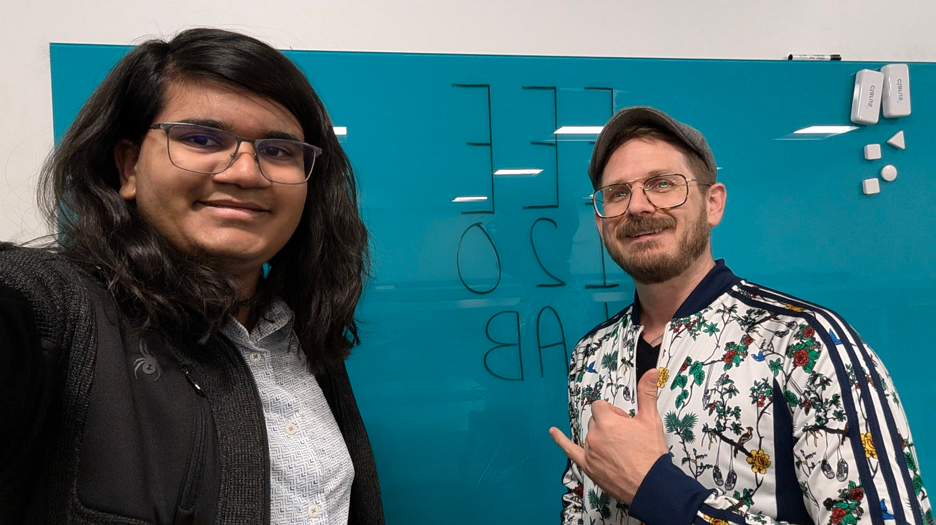

Task 0-1: Build a 2-input XOR gate using AND/OR/NOT gates in Digital
Include a picture of your Digital circuit here:
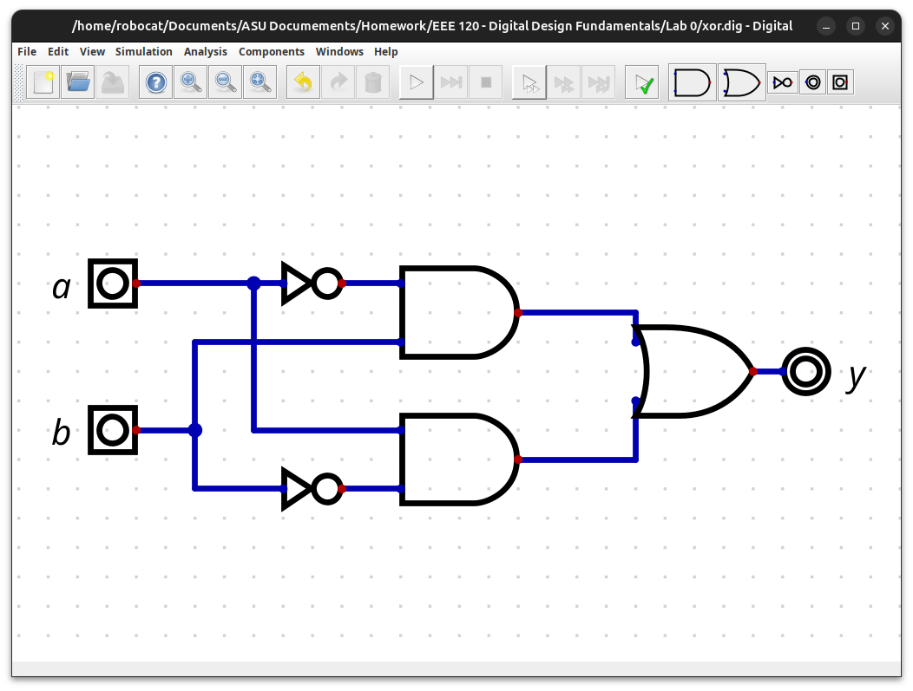
Please comment on the single biggest issue you were facing when designing the circuit.
Learning how to move gates that I already added. Clicking them adds a wire, and it took me a bit to figure out that I should ctrl+click them.

Task 0-3: Export the design and simulate in Verilog
Include a picture of your GTKWave simulation (timing diagram) here:
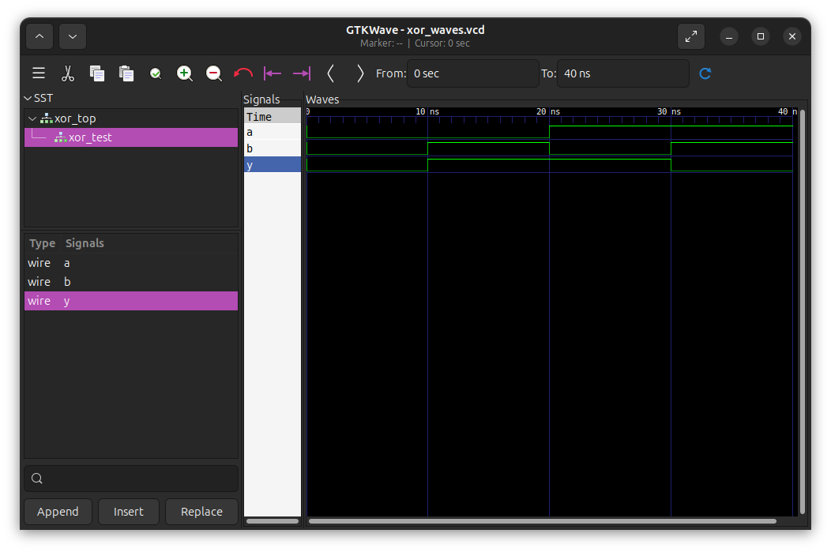
Please answer the following questions:
- How do you expect the output of a 2-input XOR gate to behave?
  - When either of the inputs are high, the output is high, and when both of them are high or both are low, the output is low. Essentially a XOR b is low if a and b are the same, and high if they are different.
- What tests did you perform to verify your logic circuit?
  - There are four possible states for two bits (00, 01, 10, 11). Each of these inputs were imputed into the circuit and the outputs were observed (0, 1, 1, 0; respectively).
- Did the circuit behave as expected? If no, what was wrong?
  - The circuit behaved as I expected.

Task 0-4: Create a video and submit your report
Record a short video showing your schematic in Digital and your waveforms in GTKWave. Be sure to show yourself in the video and show your screen. Explain how your circuit works – you need to convince the grader you did the lab and understand it! Copy and paste the link to your video below. Make sure the link is working and pointing to the correct video. Remember to include the password if required. Do NOT upload your video to Canvas. It is recommended that you use Zoom to record to the cloud, pasting the link and password below. If your circuit is not working as expected, explain in the video how it is not working and why you think it is not working.
Video Link: https://drive.google.com/file/d/1g36_KCMWX6cX20rw7xWsdkUUM8q1A6zL/view?usp=sharing
At the beginning of your recording, say your name and the lab name. Be brief in your recording. Submit the completed template to Canvas.
Make sure all your files are in the Lab0 directory. Create a zip file of the Lab0 directory. Remember to turn in the zip file AND your completed template on Canvas!
Do not include the video in the zip file! This makes the file very large and you run the risk of the zip file not uploading or taking so long to upload that your submission will be late. Remember that the submission is dated at the time the upload completes, not when it starts!

Lab 0: Lab Report Grade Sheet

Name: | Dylan Shah

NOTE: You submit the zip file in order to show your work.
If the zip file is not submitted you will receive a 0 for this lab!
Instructor Assessment
Grading Criteria | Max Points | Points Lost
Description of Assigned Tasks, Work Performed & Outcomes Met
Task 0-0: Visit the Lab | 5
Task 0-1: Build a 2-input XOR gate using AND/OR/NOT gates | 10
Task 0-3: Export the design and simulate in Verilog | 10
Task 0-4: Create a video and submit your report | 10
zip file upload (all points lost if missing or incomplete)
 | Points Lost
Lab Score (35 points total) | Late Lab
 | Lab Score

